**Task 1: System Monitoring System**

**Goal:**

Install & configure tools to monitor **CPU**, **memory**, **processes**, and **disk usage**. Save logs for reporting.

**Step 1: Output of htop command**

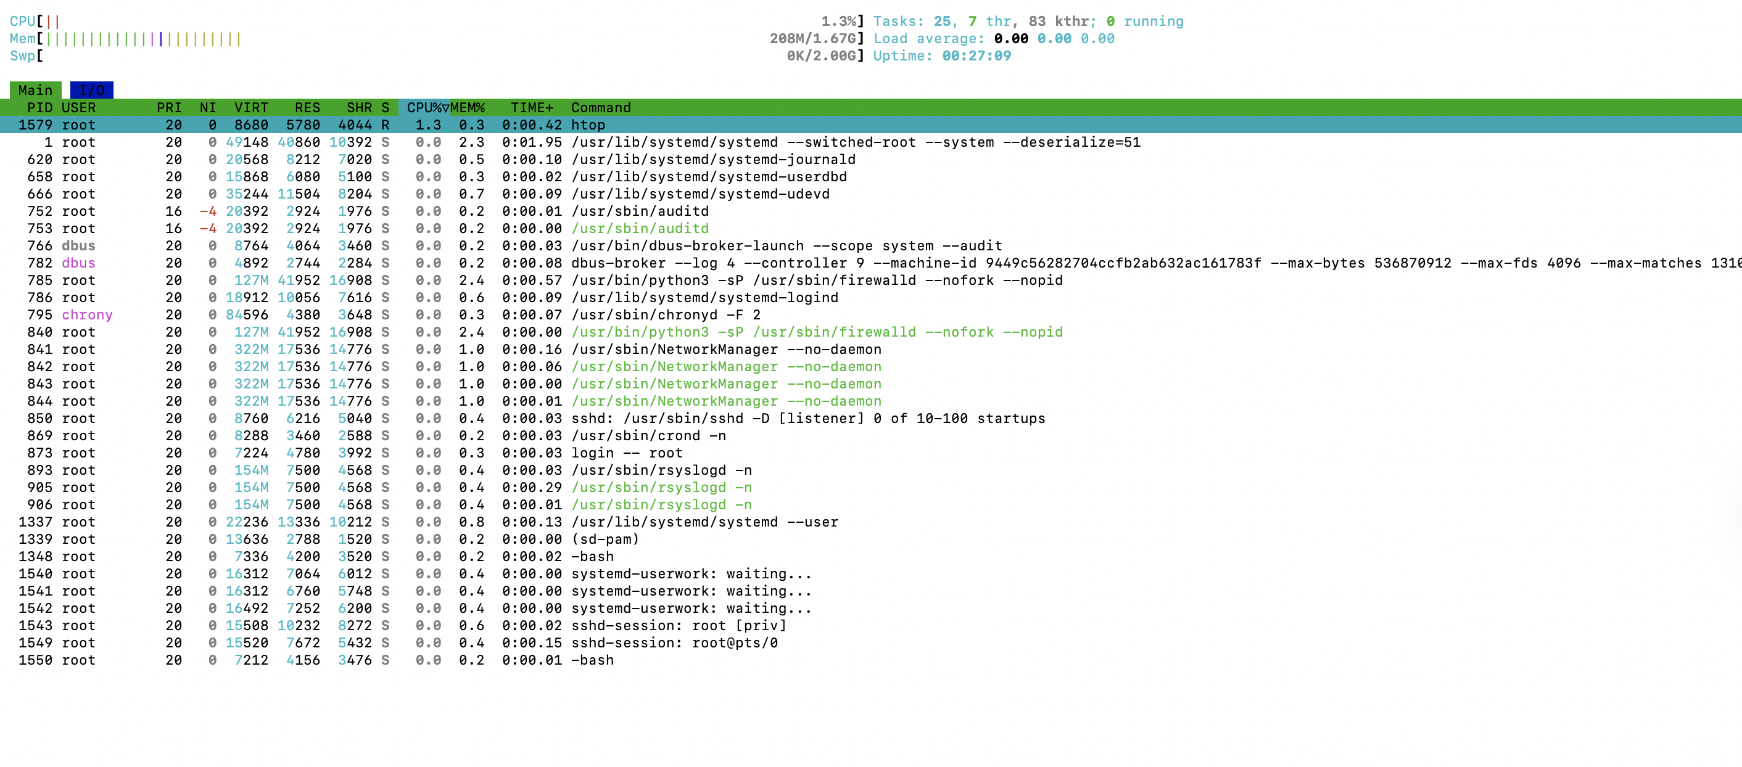

**Step 2:** Monitor Disk Usage

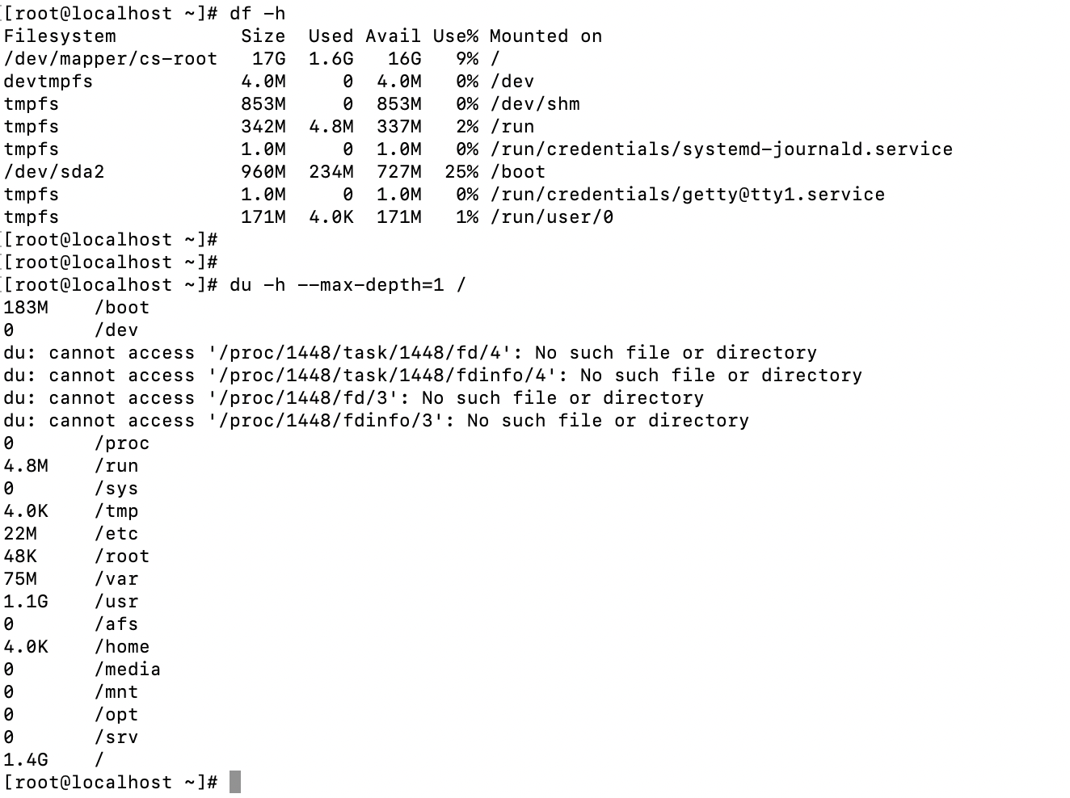

**Step 3: Identify Resource-Intensive Processes by CPU and memory**

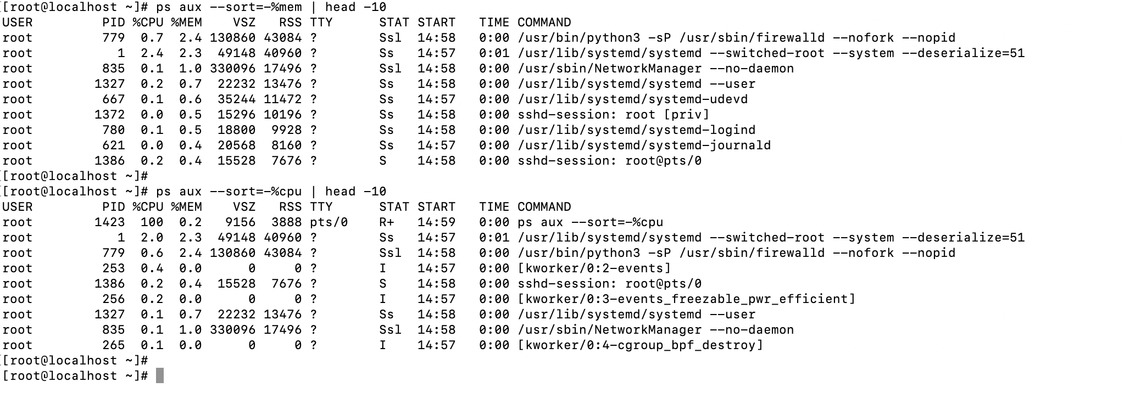

**Step 4: Automate the script and Make it executable:**

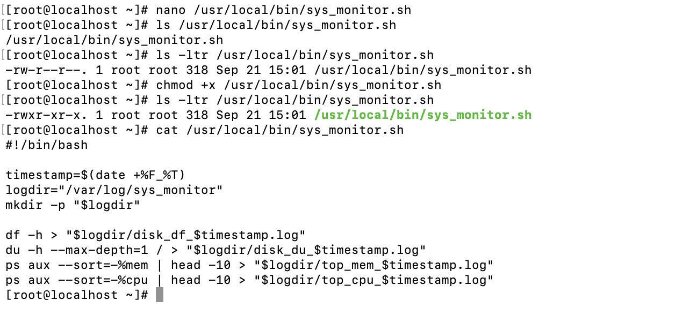

System logs:

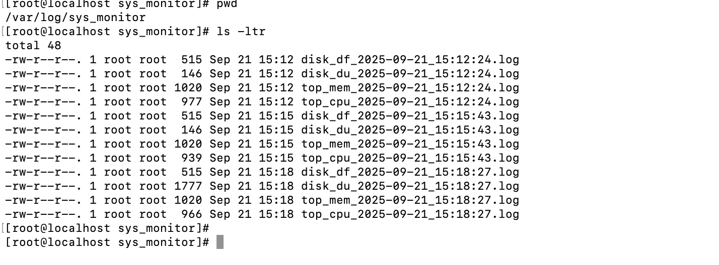

**Step 5 : schedule crontab at daily midnight**

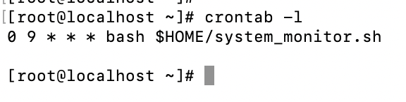

**Task 2: User Management and Access Control**

**Goal:** Set up user accounts for **Sarah** and **Mike**, configure **secure directories**, and implement **password policies** (expiration and complexity) to meet security standards

**Step 1: Create Users with /home directory**

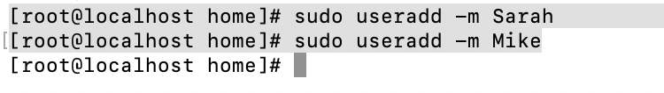

**Set secure password:**

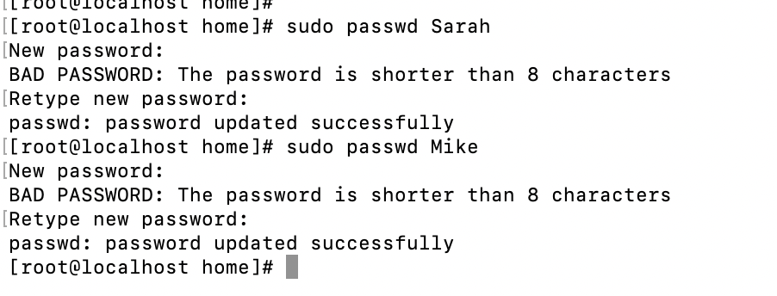

Step 2: Set Up Isolated Directories and **Set correct ownership** & Permission

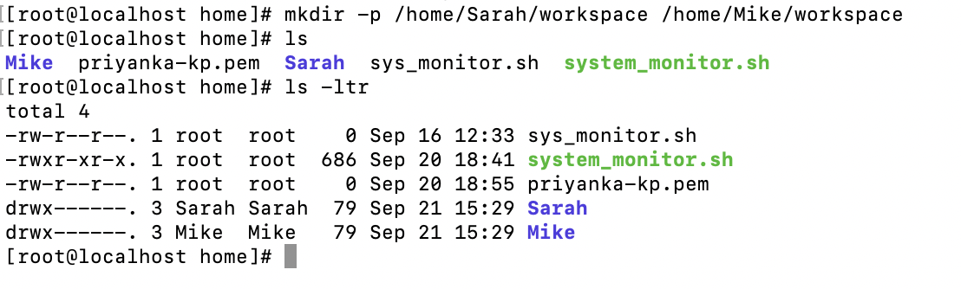

[root@localhost home]# chmod 700 /home/Sarah/workspace

[root@localhost home]# chmod 700 /home/Mike/workspace

[root@localhost ~]# chown Sarah:Sarah /home/Sarah/workspace

[root@localhost ~]# chown Mike:Mike /home/Mike/workspace

Step 3: Enforce Password Policies

Made changes in file **/etc/login.defs** so that password will expire in 30 days

PASS_MAX_DAYS 30

PASS_MIN_DAYS 0

PASS_MIN_LEN 8

PASS_WARN_AGE 7

2. Apply these policy to Sarah and Mike

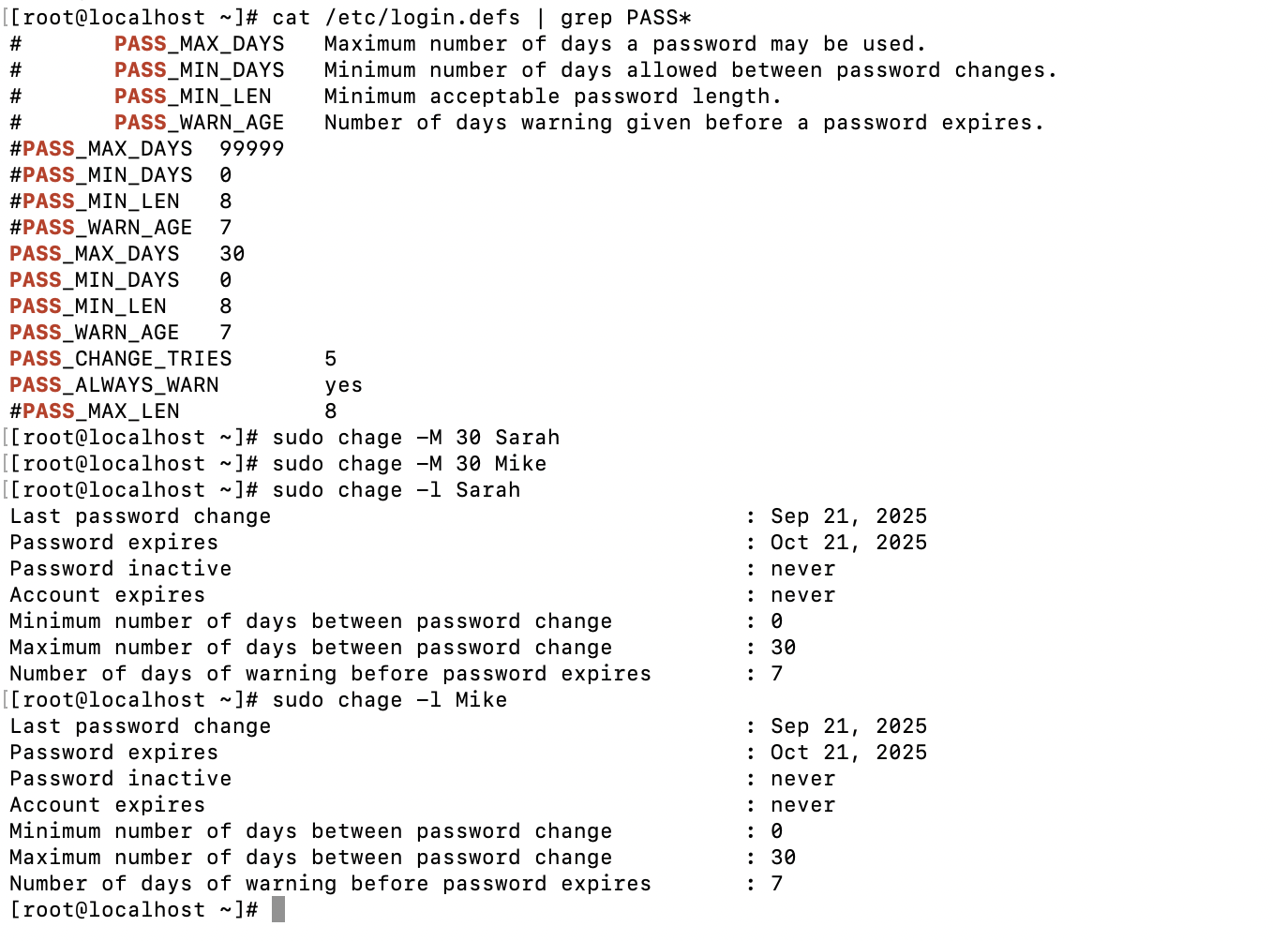

**Install pwquality module**:



**Edit PAM configuration**:

Modify or add password requisite pam_pwquality.so retry=3 minlen=8 ucredit=-1 lcredit=-1 dcredit=-1 ocredit=-1

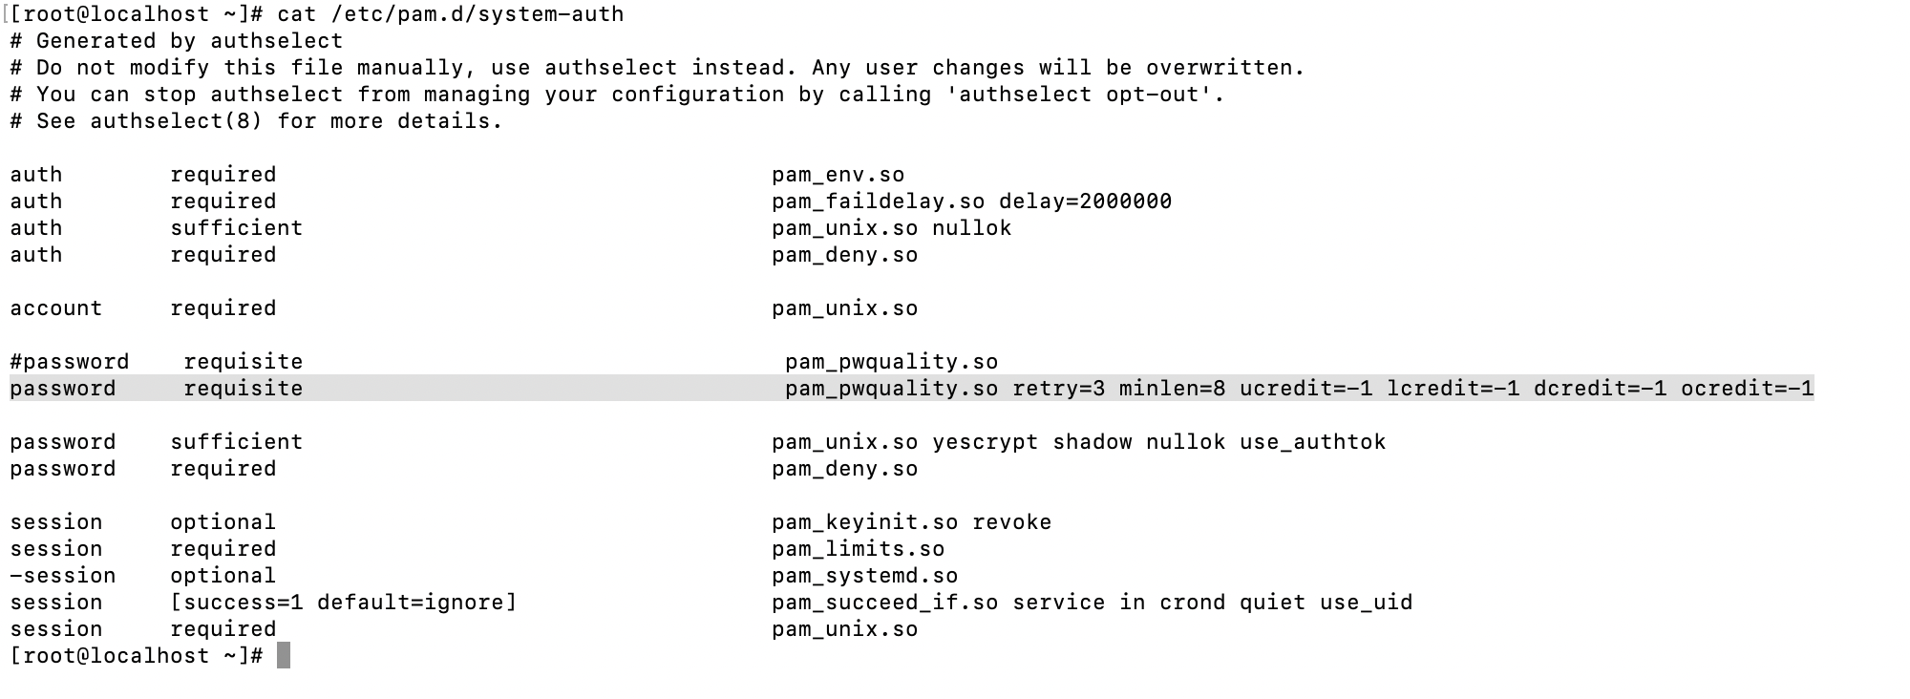

Automated script:

Created automated script with

Name: /usr/local/bin/setup_user_management.sh

Log file: /var/log/user_setup.log

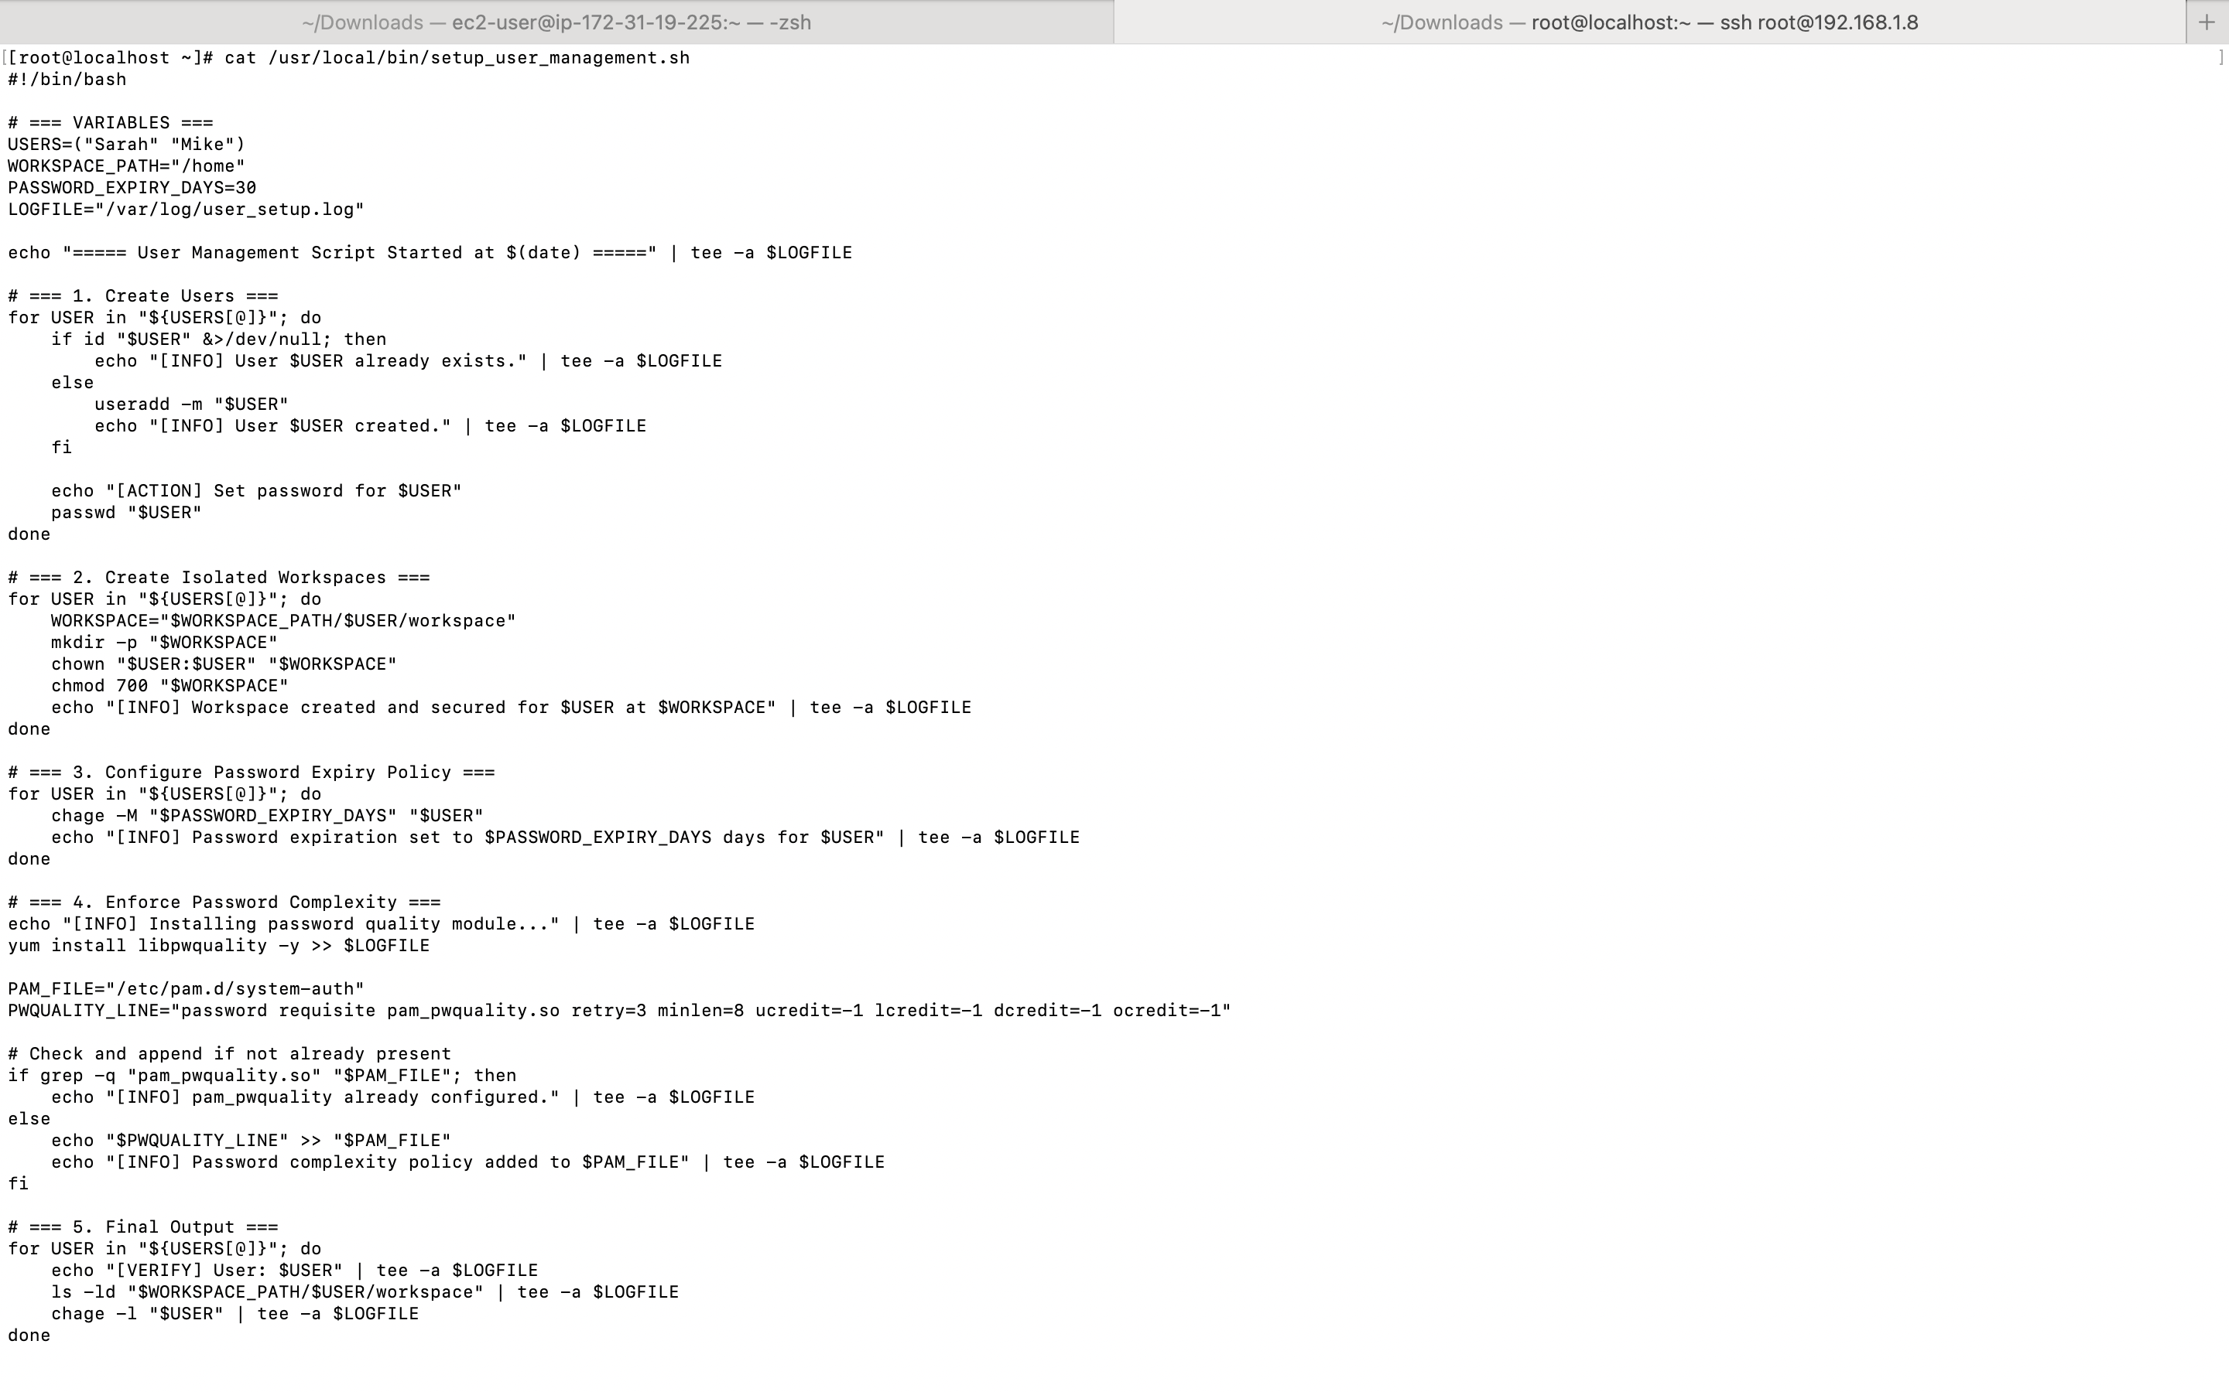

Executed the script:

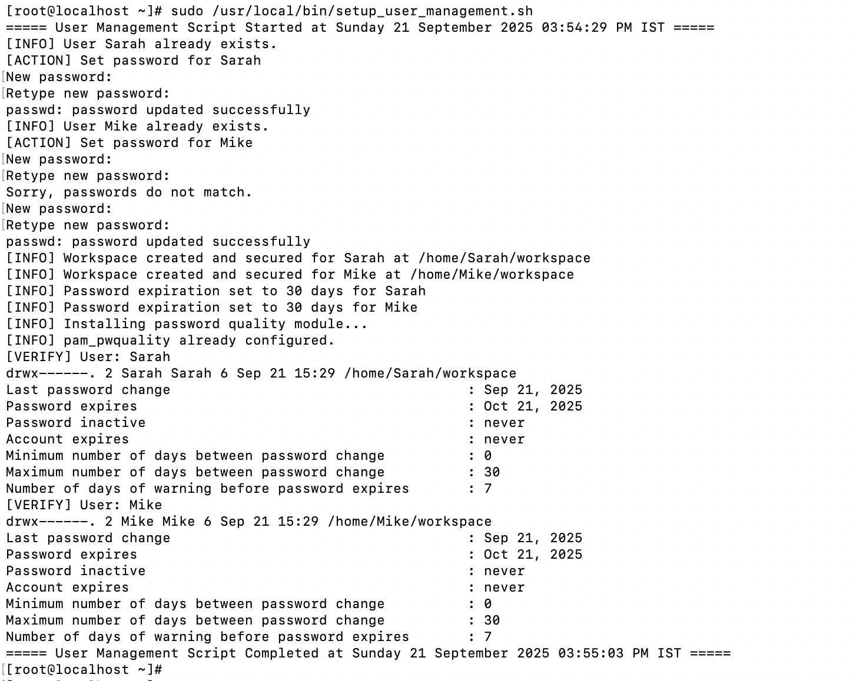

Log file:

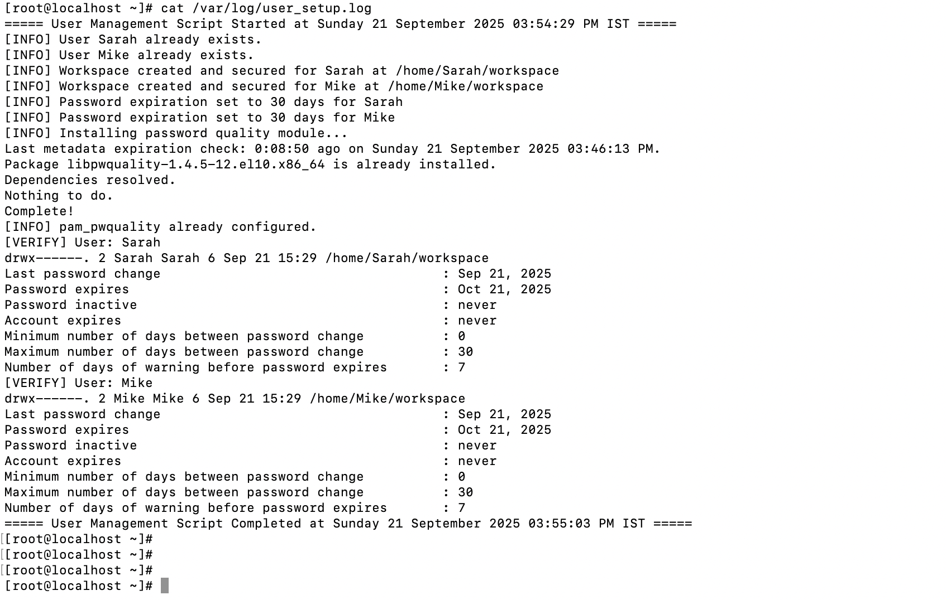

**Task 3: Backup Configuration for Web Servers**

**Step 1:**

* **Sarah (Apache):**

**Goal:**

Automate backups of:

* Apache config: /etc/httpd/
* Apache web root: /var/www/html/

Backups must:

* Run **every Tuesday at 12:00 AM**
* Be saved to /backups/
* Be compressed as:  
  apache_backup_YYYY-MM-DD.tar.gz
* Include a log verifying backup content

**Create the script file:**

Created script “/usr/local/bin/apache_backup.sh” and provided execute permission

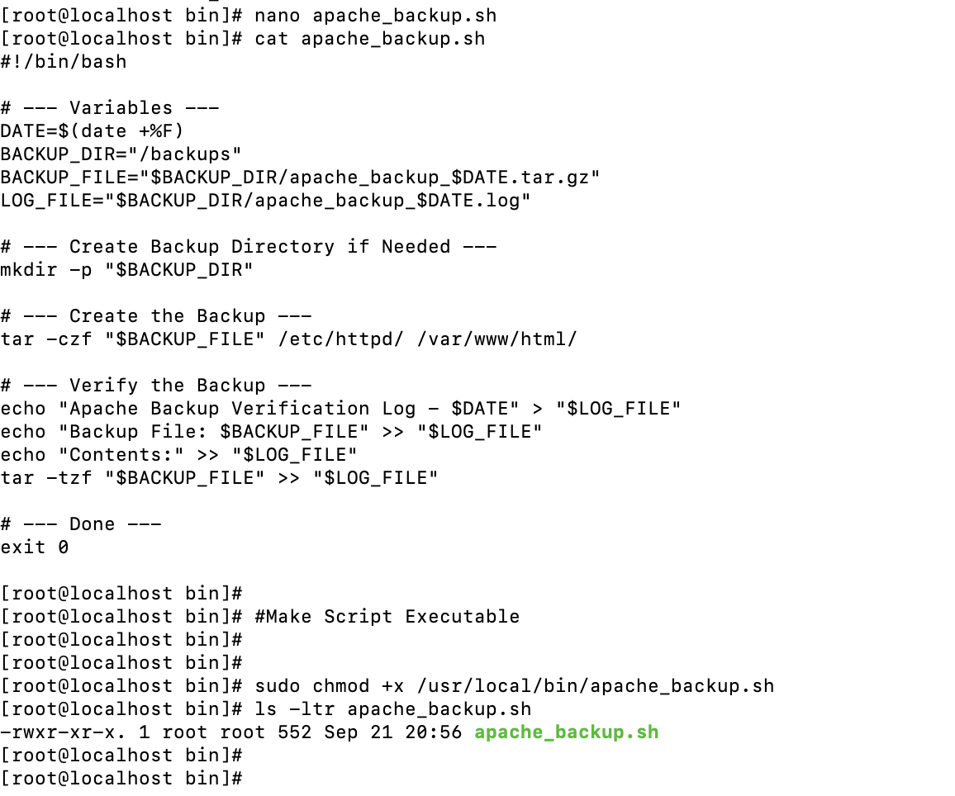

**LOG file**

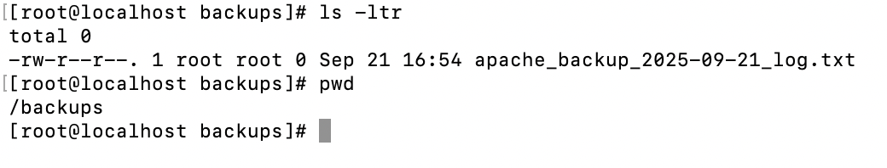

**Scheduled crontab:**

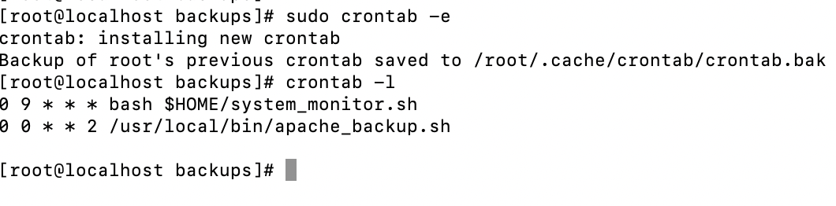

**Executed script, checked log file and backup file**

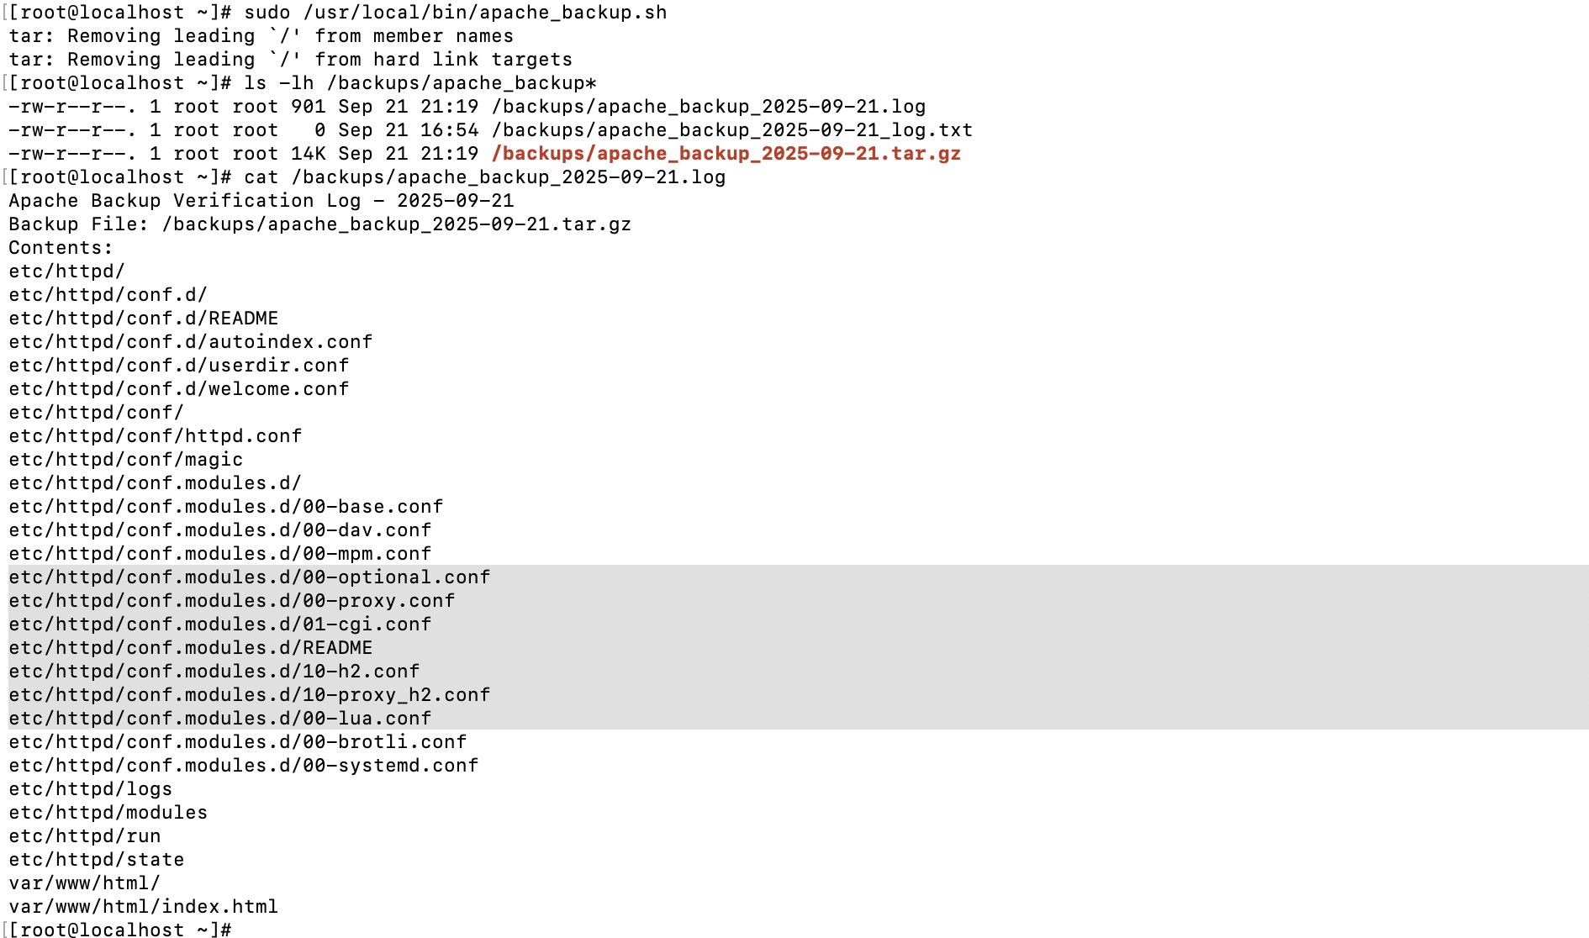

Step 2:

* **Mike (Nginx):**
  + /etc/nginx/
  + /usr/share/nginx/html/

**Create Backup Script**

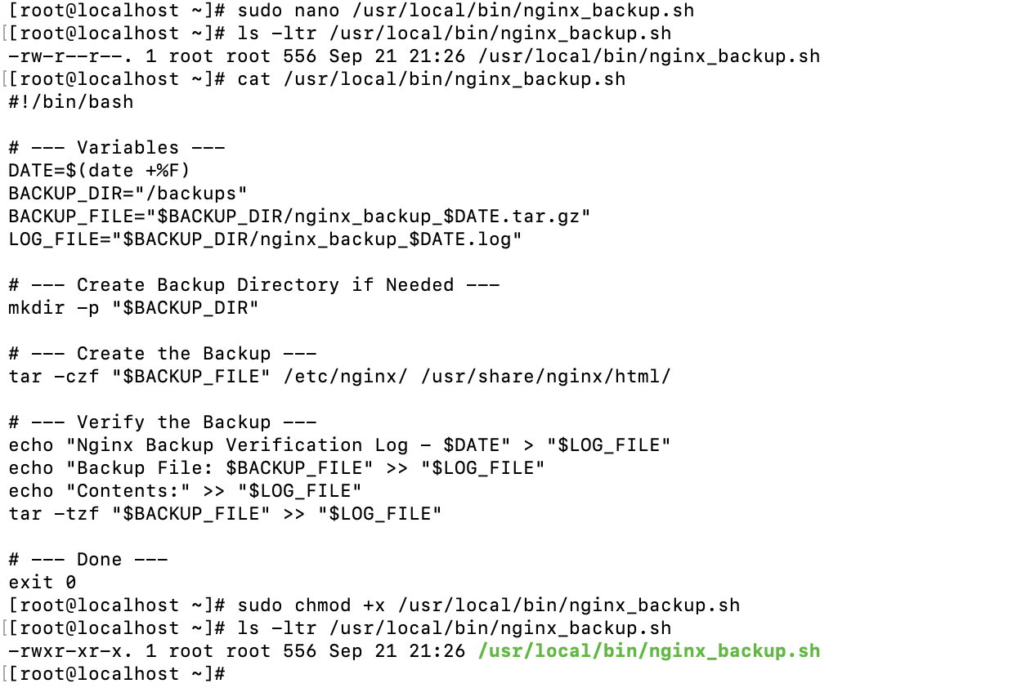

**Execute script**



**Schedule Cron Jobs (Tuesdays @ 12:00 AM)**

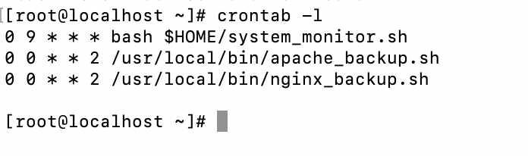

Backup Verification

